Room 2 Camp Gear List
Expect the weather to be changeable. Make sure you’re prepared with plenty of warm clothing and plenty of changes of clothing
ALL CLOTHING SHOULD BE CLEARLY NAMED!!!!!
Tick when packed
Suitable footwear for walking (2 pairs) and a pair that will get wet. Your oldest pair must have laces for the assault course. They will get muddy and wet.
Gumboots - optional
Suitable clothing for indoors
Socks – plenty (at least 8 pairs)
Track pants and long trousers. These will get wet so have back-ups. No jeans please (unless for the Berwick Ball).
Warm underwear, eg. thermals for night time activities and cold weather
Warm jerseys/sweatshirts/polar fleeces
Sun hat, beanie
Waterproof jacket
Shorts & T-shirts
Pyjamas
Swimming togs & a wetsuit if you have one (for kayaking)
1 set of clothes for the assault course. They may get ripped or need to be thrown out.
Tidy clothing for the glow-in-the-dark Berwick Ball
Toilet bag, towels (2 or 3) and personal gear
Sunscreen and insect repellent
Plastic drink bottle and lunch box filled with morning tea and a big lunch for the first day.
Small day pack (your school back pack would be ideal)
Torch (for night games)
All essentials for the camp concert
Sleeping bag, pillow and pillow case
Shoes or slippers suitable for indoor use (no outdoor shoes are allowed inside)
Plastic bags – at least 4
Baking – named container please – Students are encouraged to bake their own and this will form part of the homework in the week before camp.
Personal medication, eg. hayfever tablets

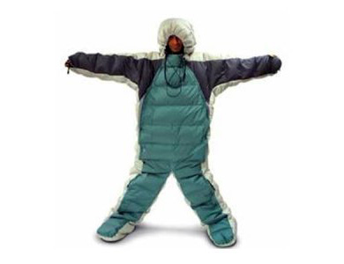
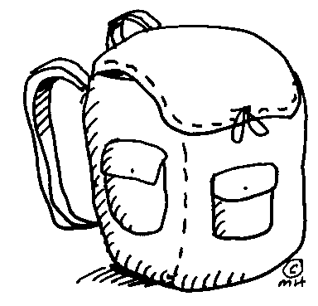
Avoid designer gear and leave all electronic equipment at home (unless it is needed for the camp concert).
Get second hand gear instead of buying new.
See Mr Olsen if there is anything you can’t get and would like to borrow.

